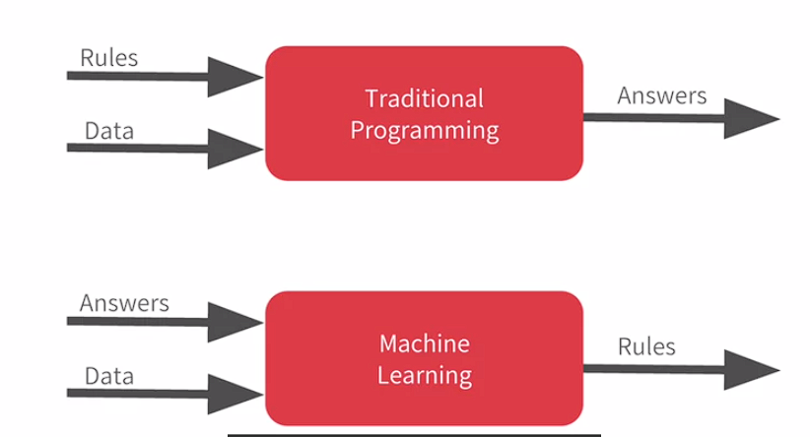

The ‘Hello World’ of neural networks

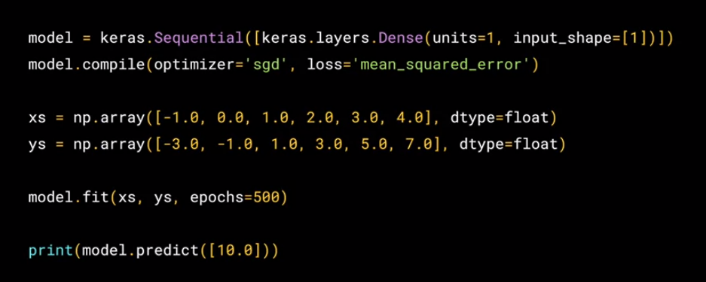

# From rules to data

In these videos, you were given an introduction to the concepts and paradigms of Machine Learning and Deep Learning. You saw that the traditional paradigm of expressing rules in a coding language may not always work to solve a problem. As such, applications such as computer vision are very difficult to solve with rules-based programming. Instead, if we feed a computer with enough data that we describe (or label) as what we want it to recognize -- given that computers are really good at processing data and matching patterns -- then we could potentially ‘train’ a system to solve a problem. We saw a super simple example of that: fitting numbers to a line. So now, let’s go through a notebook and execute the code that trains a neural network to learn how a set of numbers make up a line. After that, you will feed the trained network a new data point and see if it correctly predicts the expected value.

Quiz

